Design Chassis

# Vocabulary :

Châssis : Frame

Rigidité : Stiffness

Modèle poutre : Beam model

Contrainte : Constraint

Limite d’élasticité : Yield strength

Torsion : Torsion

Side impact : 2x3 tubes sur les côtés du cockpit

Bulkhead : Cadre avant du chassis composé de 5 tubes

Front/Main Hoop : Arceau avant/arrière

Bracings : Tubes qui soutiennent les arceaux avant et arrière

Sleeved joint : Liaison entre le châssis et les bracings du main hoop, équivalent à un encastrement.

Souder : To weld

Soudure : A weld

Couple : Torque

Gabarit : Template

# Objective :

1. To structure the car and ensure the position and the sustainability of other systems.
2. To ensure the pilot security.

# Conception steps :

1. The rules impose few extremal dimensions as the size of the cockpit, the front of the frame and also the position of tubes on the side impact.
2. Suspension preference based conception.
3. Make the integration of the engine easier thanks to removable bracings.
4. Improve the pilot position making it more comfortable. Minimization of the front hoop in order to improve the pilot visibility.

# Numbers :

1. Stiffness

Target : between 1000 and 1500 Nm/deg

Simulated : 1114 Nm/deg

Measured : 1205 Nm/deg

1. Weight when painted and equipped

Target : between 39 and 42 kg

Simulated : 40,6 kg

Measured : 41 kg

1. Steel : 25CD4S

Yield strength : 7.108 N/m²

# Simulation hypothesis

* Elastic behaviour
* Small displacement
* Welds infinitely stiff
* No dynamic phenomenon
* Beam model

# Simulation pictures

NB : Except for torsion , all load cases come from MécaMaster.

* Torsion

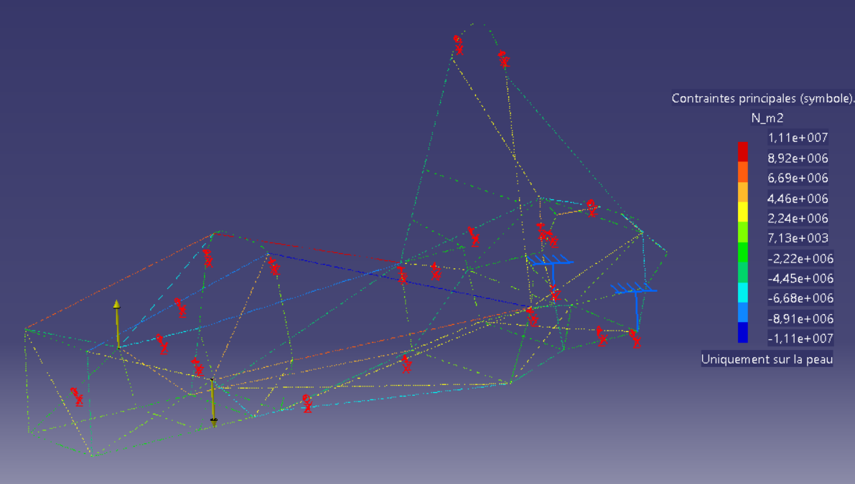

* Acceleration 0,77g

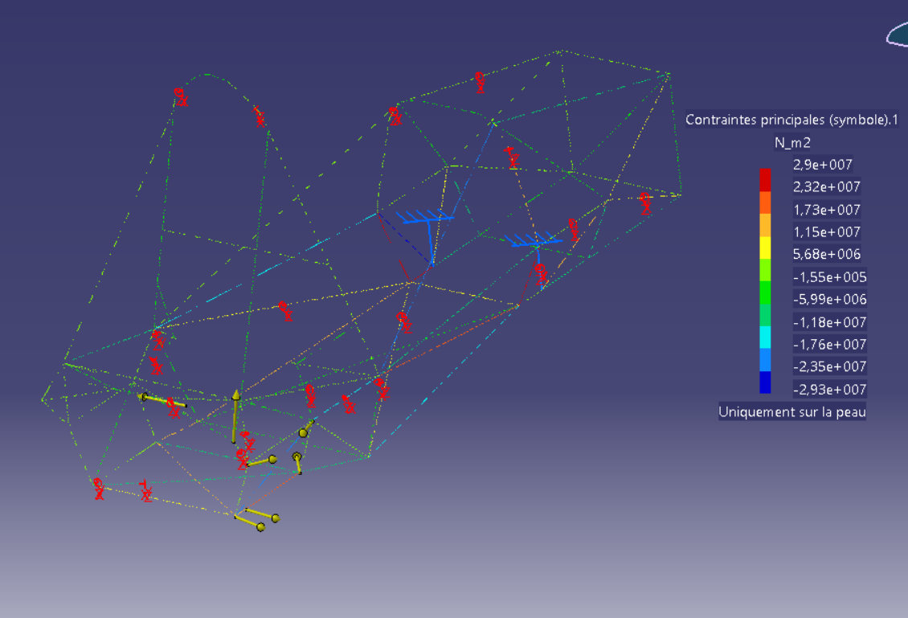

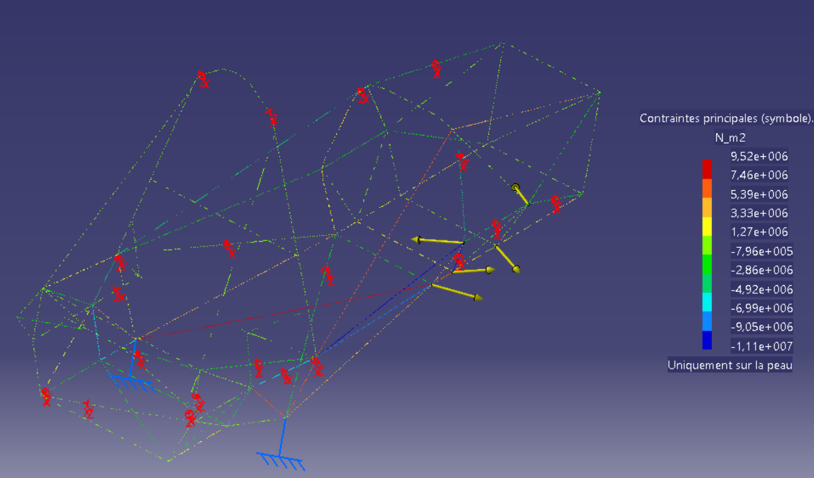

* Brake 2g

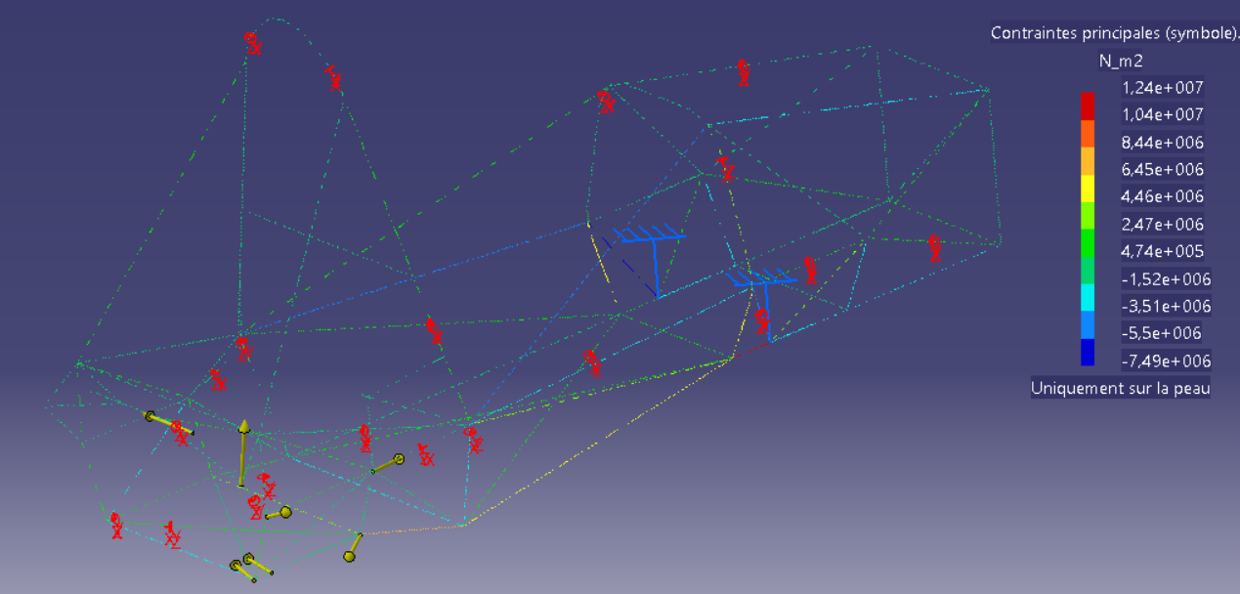

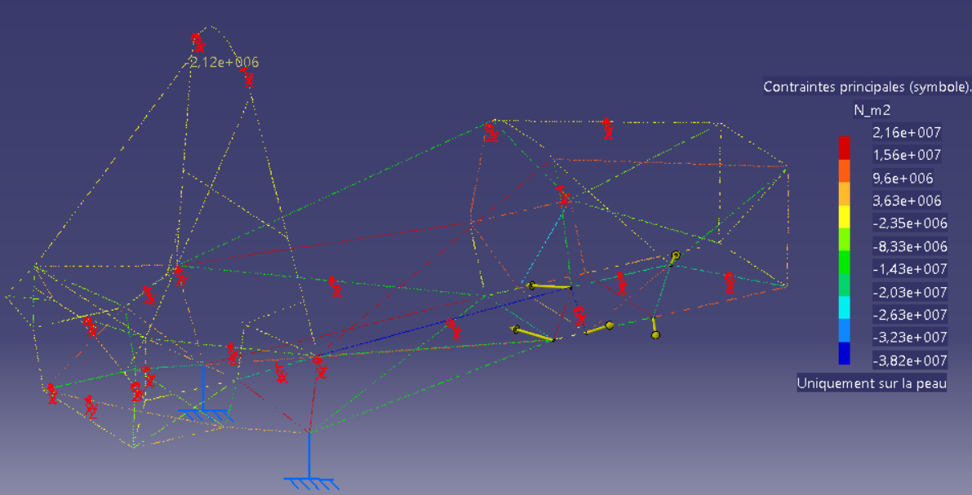

* Bump 3g

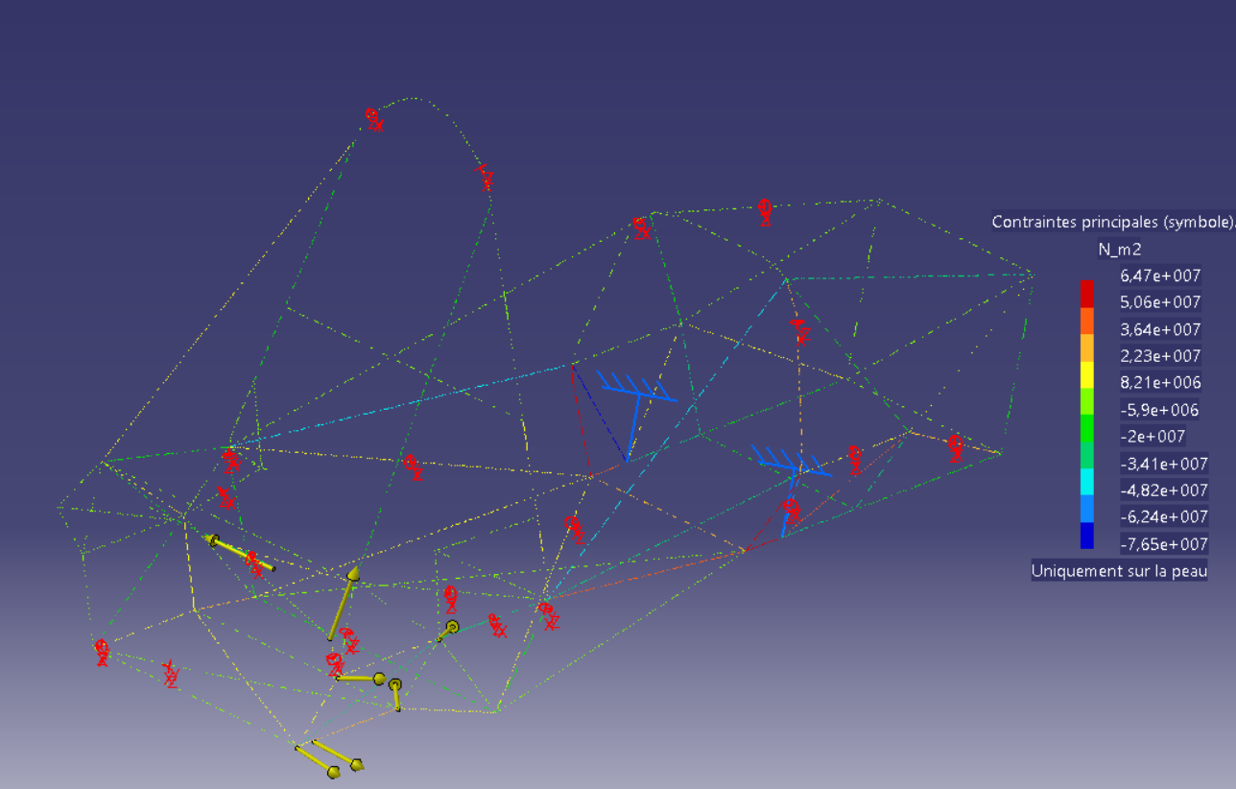

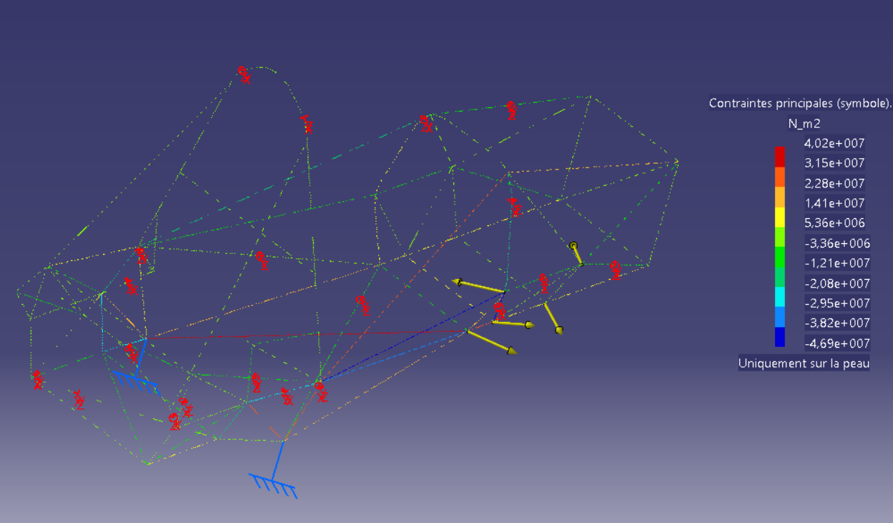

* Left turn 2g

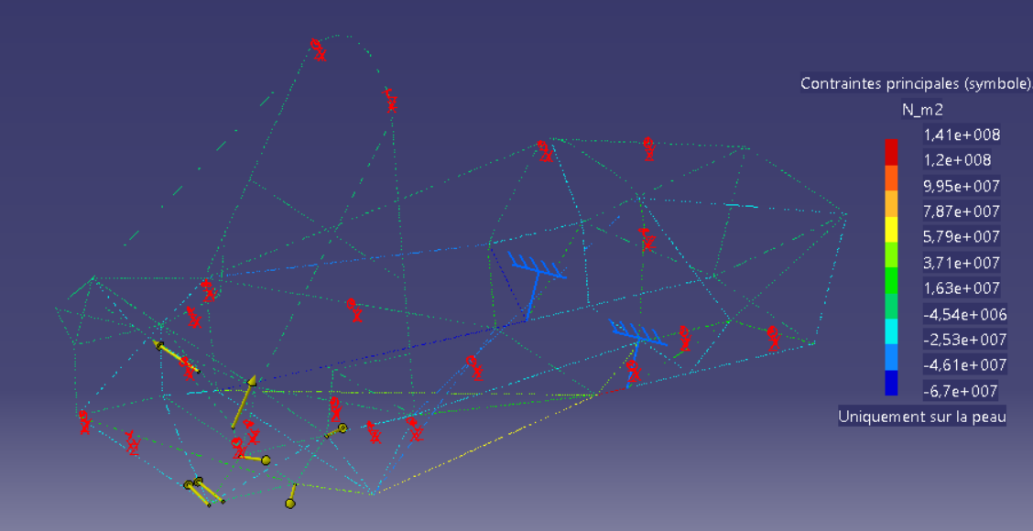



* Left turn 1g and brake 1g

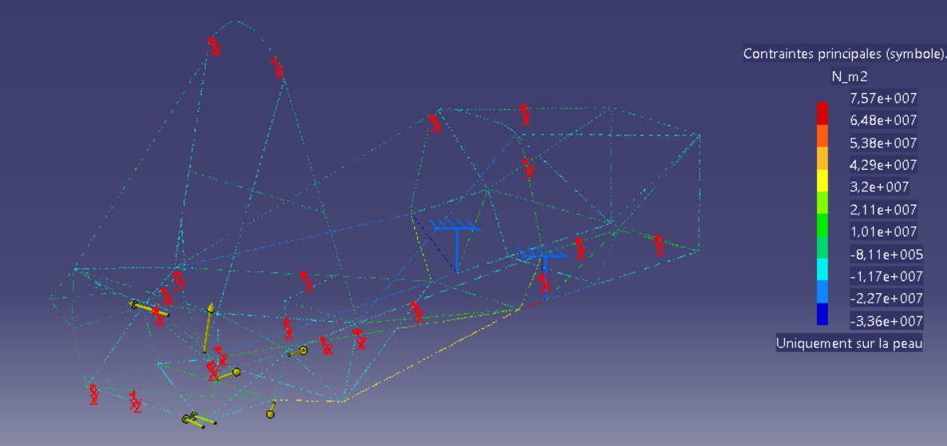

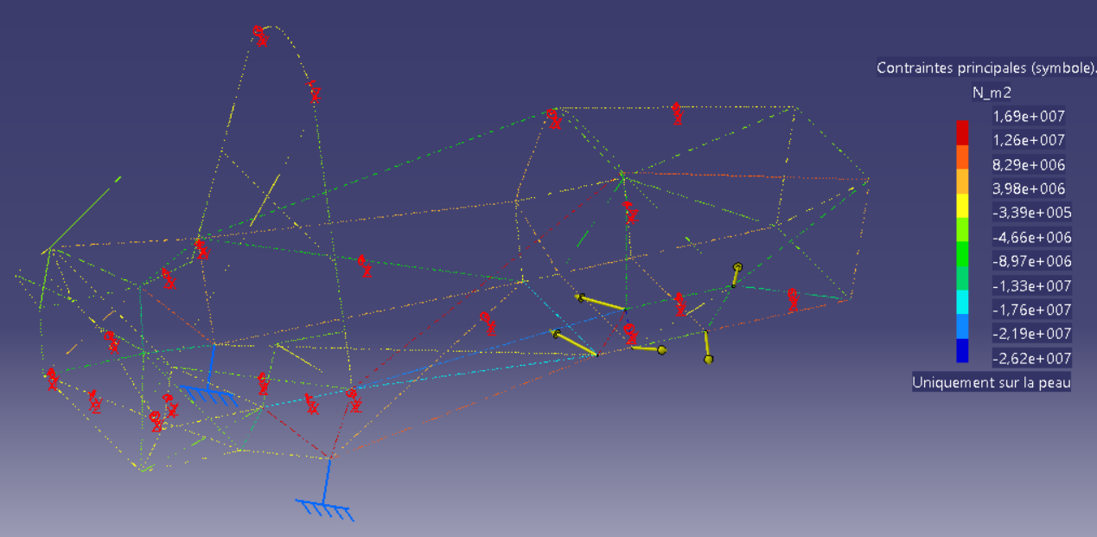

# Stiffness measure

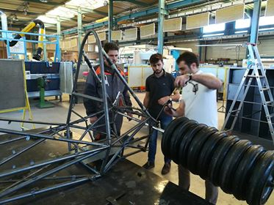

The measure of the stiffness was taken in two times. The first one with the front and the cockpit of the frame, blocking the back. Then the second one applying a torque at the back, blocking the front.

The difference between the simulated and the measured values may come from the boundaries conditions that are not exactly the same.

# Equipment positioning

Templates were used to make the equipment weld more precise and also easier. Here an example with the suspension equipment.

Une image contenant personne, intérieur, mur, cuisine

Description générée avec un niveau de confiance très élevé

# Stiffness coefficient

Frame = 3 series torsion springs

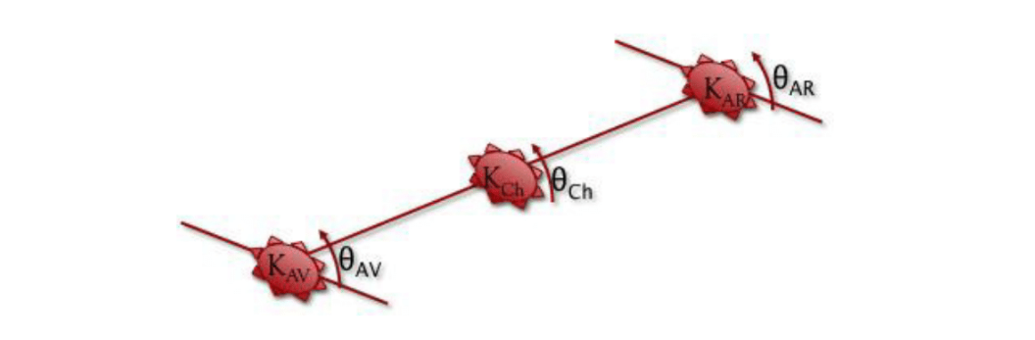

Where K=stiffness and Θ=angle. We also define and respectively the stiffness and the angle of the car.

In order to simplify the equations, we suppose . It gives us the following equations :

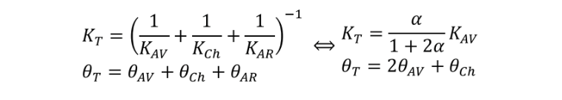

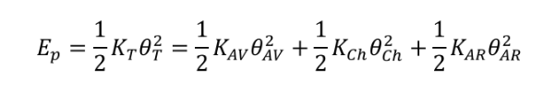

Finally,

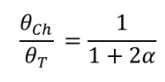

If we want to keep between 10% and 15%, we have to take α between 3 and 5.

# Pilot position

Une image contenant transport, ciel, intérieur

Description générée avec un niveau de confiance élevé

# Sleeved joint

It’s supposed to have the same efficiency as a weld.

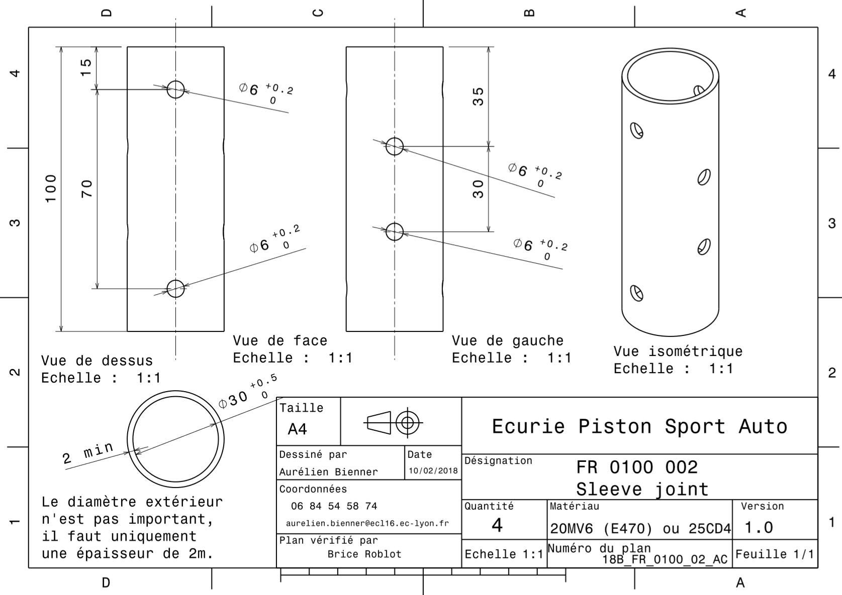

Remarque :

Image chassis + pilote

Annexe sur calcul rigidité